With the increase in advancements & technologies in this modern-day world people unintentionally have become ignorant of the prevailing climate change. The usage of plastic products has increased by many folds and especially single-usage plastics because of their flexibility & cost-effective nature, more than 40 percent of plastic is used just once, then tossed but what we oversee in the long run is that it does worse to us than good. This single-use plastic does not break down completely, instead, they photodegrade and turn into microplastics that continuously absorb toxins & pollute the environment for a long period of time. According to National Geographic by 2050, virtually every seabird species on the planet will be eating plastic**.** The effect of plastics as quoted in the recent study conducted by The UN- “The impacts of plastic production and pollution on the triple planetary crisis of climate change, nature loss and pollution are a catastrophe in the making. With exposure to plastics harming human health, and potentially affecting fertility, hormonal, metabolic and neurological activity, while open burning of plastics contributes to air pollution.”

Moreover, the conferences which are held to reduce the impact of plastics on the environment use substances that are essential for a conference made of plastics. As we all must have heard “Journey of a thousand miles begins with a single step.” So, if we focus on how to reduce the use of single-use plastics in the conferences held all over the world be it business-related, government conferences, or any other meetings, it would be a major step towards creating a sustainable environment & a better place for us to live in.

**10 WAYS TO REPLACE SINGLE-USE PLASTICS IN CONFERENCES:**

1. **Invitation cards:**

The cards sent to the delegates for inviting them to the conference contain all the information about the conference. These invitation cards contain plastic in various forms. Instead of sending these physical invitation cards, E-cards should be sent to the delegates. This will reduce the cost of the event as well as reduce plastic trash and lessen the usage of paper as well which will lead to lesser cutting of trees.

1. **The ID Cards:**

Let’s start with the ability to enter a conference and by this, I mean that the conferences which are held are exclusive to only a bunch of people. Here the role of ID cards comes into play as only the people having these ID cards are allowed to attend the meeting and the necessary information about the identity of these people is written on them like their names, designation, and their picture. Most of the conferences have these ID cards made up of plastic. An environmentally sustainable brand called Uneako has come up with the idea of replacing these plastic-made ID cards with ID cards made of waste paper which will result in replacing plastic as well as reusing paper. This will prove to be a sustainable alternative to the plastic ID cards which are in use currently.



.

1. **Banners:**

The banners with the name of the meeting written over them hung at the conference venue are often made up of plastic. The banners can either be made of cardboard or LED screens can be placed at the conference venue with the conference details displayed over it in a slideshow manner.

1. **Water bottles:**

The dignitaries attending the conference are presented with a water bottle each to stay hydrated during the meeting. These water bottles are generally made of single-use plastics. Do you know around the world nearly a million plastic beverage bottles are sold every minute? People tend to take merely a sip of water from these and then they are thrown into the trash bins. This results in the creation of a huge quantity of plastic waste and the wastage of clean drinkable water. Instead of this, before the meeting, a mail can be sent to the attendees that they have to bring their own metallic or wooden water bottles or a water dispenser should be installed with reusable cups of it so that if someone feels like drinking water can walk up to the dispenser or can ask a peon to bring them water.

1. **Bouquets:**

In these conferences, bouquets are given to dignitaries as a token of gratitude for attending the meeting. These bouquets usually come in plastic wrapping and the flowers used in them wear off in merely a week’s time. So, to create less trash, Uneako has created a product named Pollution Solution which is a pack of 10 water-soluble capsules containing seeds of vegetables that can be sown in pots or a garden that will result in a full-fledged plant. This will encourage them to plant trees and the plastic wrapping which would have been thrown in the bins is also not created. BINGO!



1. **Folders:**

In conferences, the attendees are also provided with folders to keep their documents aligned neatly. These folders are generally made up of plastic so here comes an opportunity to replace these plastic folders with biodegradable paper ones. They are cost-effective and at the same time hitting pollution in two ways that are not creating more plastic waste and recycling waste paper.

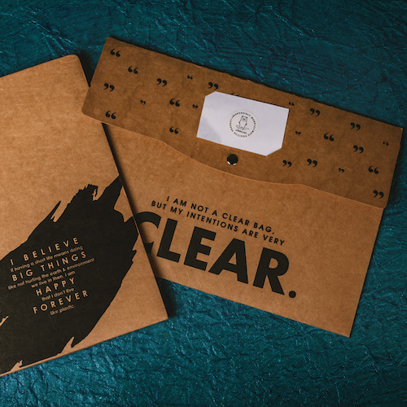

1. **Plastic pens:**

The stationary which is used during conferences is majorly made of plastic. Pens made of up of plastic can readily be seen in the hands of attendees of these conferences. A sustainable alternative to these plastic pens is pens made up of paper. These pens can be seen in the hands of teenagers these days as they are environment friendly and gives teens a sense of saving the planet as well.



1. **Tea & Coffee Sachets:**

Beverages like tea & coffee are generally served to the people attending conferences. Usually, tea bags & coffee bags are given to the attendees wrapped individually in plastic sachets. Instead of using these beverage bags wrapped in plastic sachets, the conference organizers can buy these items in bulk, and these beverages then can be served to the people in glassware.

1. **Food Packets:**

Did you know the largest market for plastics today is packaging materials? That rubbish now accounts for nearly half of all plastic waste generated globally—most of it never gets recycled or incinerated.If food packets are being provided at the conference, the organizers should make sure that the food packets do not contain plastic in any form alone with them like plastic wrappers because any kind of plastic associated with the food will harm both, human health, and the environment. Paper packaging should be used instead of plastic wrappers.

1. **Goodie Bags:**

At the end of the conference, the delegates are presented with some goodie bags which contain gifts for the attendees. For the sake of the environment, the goodie bag should contain environment-friendly plastic-free goods to promote sustainable commodities. Also, the packaging should be done in a plastic-free manner, using paper or jute bags or in a more premium way metallic or wooden boxes.

